**AI-BASED LOCALIZATION AND CLASSIFICATION OF SKIN DISEASE WITH ERYTHEMA**

**IBM PROJECT REPORT**

Submitted by

VISHAL D (722819104163)

HARI KRISHNA MOORTHY T (722819104040)

JYOTSNA OP (722819104052)

GAJENDAR SINGH J (722819104)

In partial fulfilment for the award of the degree of

BACHELOR OF ENGINEERING

in

COMPUTER SCIENCE AND ENGINEERING

SRI ESHWAR COLLEGE OF ENGINEERING

COIMBATORE

# ABSTRACT

Skin diseases are more common than other diseases. Skin diseases may be caused by fungal infection, bacteria, viruses or allergy etc. The advancement of lasers and photonics based medical technology has made it possible to diagnose the skin diseases much more quickly and accurately. But the cost of such diagnosis is still limited and very expensive. So, image processing techniques help to build automated screening system for dermatology at an initial stage. The extraction of features plays a key role in helping to classify skin diseases. Computer vision has a role in the detection of skin diseases in a variety of techniques. Due to deserts and hot weather, skin diseases are common in Saudi Arabia. This work contributes in the research of skin disease detection. We proposed an image processing-based method to detect skin diseases. This method takes the digital image of disease effect skin area, then use image analysis to identify the type of disease. Our proposed approach is simple, fast and does not require expensive equipment other than a camera and a computer. The approach works on the inputs of a colour image. Then resize the of the image to extract features using pretrained convolutional neural network. After that classified feature using Multiclass SVM. Finally, the results are shown to the user, including the type of disease, spread, and severity. The system successfully detects 3 different types of skin diseases with an accuracy rate of 100%.

**TABLE OF CONTENTS**

S.NO TITLE PAGE NO

1. **INTRODUCTION** 
   1. Project Overview 04
   2. Purpose 05
2. **LITERATURE SURVEY** 
   1. Existing problem 06
   2. References 07
   3. Problem Statement Definition 08
3. **IDEATION & PROPOSED SOLUTION** 
   1. Empathy Map Canvas 09
   2. Ideation & Brainstorming 11
   3. Proposed Solution 12
   4. Problem Solution fit 13
4. **REQUIREMENT ANALYSIS** 
   1. Functional requirement 14
   2. Non-Functional requirements 15
5. **PROJECT DESIGN** 
   1. Data Flow Diagrams 16
   2. Solution &Technical Architecture
6. **PROJECT PLANNING & SCHEDULING** 
   1. Sprint Planning & Estimation 21
   2. Sprint Delivery Schedule 25
7. **CODING & SOLUTIONING** 
   1. Feature 1 26
   2. Feature 2 55
8. **TESTING**

8.1Test Cases 62

8.2 User Acceptance Testing 63

1. **RESULTS** 
   1. Performance Metrics 64

**10. ADVANTAGES & DISADVANTAGES** 66

1. **CONCLUSION** 67
2. **FUTURE SCOPE** 67
3. **APPENDIX** 68 GitHub Link

**1.** **INTRODUCTION**

**1.1 PROJECT OVERVIEW**

Skin diseases are more common than other diseases. Skin diseases may be caused by fungal infection, bacteria, viruses or allergy etc. A skin disease may change texture or color of the skin. In general, skin diseases are chronic, infectious and sometimes may develop into skin cancer. Therefore, skin diseases must be diagnosed early to reduce. their development and spread. The diagnosis and treatment of a skin disease takes longer time and causes financial and physical cost to the patient. In general, most of the common people do not know the type and stage of a skin disease. Some of the skin diseases show symptoms several months later, causing the disease to develop and grow further. This is due to the lack of medical knowledge in the public. Sometimes, a dermatologist (skin specialist doctor) may also find it difficult to diagnose the skin disease and may require expensive laboratory tests to correctly identify the type and stage of the skin disease. The advancement of lasers and photonics based medical technology has made it possible to diagnose the skin diseases much more quickly and accurately. But the cost of such diagnosis is still limited and very expensive. Therefore, we propose an image processing-based approach to diagnose the skin diseases. This method takes the digital image of disease effect skin area then use image analysis to identify the type of disease.

## 1.2 PURPOSE

To overcome the above problem we are building a model which is used for the prevention and early detection of skin cancer, psoriasis. Basically, skin disease diagnosis depends on the different characteristics like colour, shape, texture etc. Here the person can capture the images of skin and then the image will be sent the trained model. The model analyses the image and detect whether the person is having skin disease or not.

## 1.3 OBJECTIVES

* To classify skin disease by using pre trained convolutional neural networks.
* To develop an android application to help build automated screening system for dermatology.
* To identify the type of skin disease by image using image processing-based techniques.
* The results are displayed to the user, including the type of disease and their severities

## 2. LITERATURE SURVEY

The literature review is **a comprehensive summary of previous research on a topic**. The literature review surveys scholarly articles, books, and other sources relevant to a particular area of research. The review should enumerate, describe, summarize, objectively evaluate and clarify this previous research.

### 2.1 EXISTING PROBLEM

Skin diseases may be caused by fungal infection, bacteria, allergy, or viruses, etc. The advancement of lasers and Photonics based medical technology has made it possible to diagnose the skin diseases much more quickly and accurately. But the cost of such diagnosis is still limited and very expensive.

It is a process of collecting and interpreting facts, identifying the problems, and decomposition of a system into its components. It is a problem-solving technique that improves the system and ensures that all the components of the system work efficiently to accomplish their purpose.

### 2.2 REFERENCES

[1].Arifin, S., Kibria, G., Firoze, A., Amini, A., & Yan,H.(2012) “Dermatological Disease Diagnosis Using Color Skin Images.”Xian:Internatinal Conference on Machine Learning and Cybernetics.

1. Yasir, R., Rahman, A., & Ahmed, N. (2014) “Dermatological Disease Detection using Image Processing and Artificial Neural Network. “Dhaka: International Conference on Electrical and Computer Engineering.

1. Santy, A., & Joseph, R. (2015) “Segmentation Methods for Computer Aided Melanoma Detection.” Global Conference on Communication Technologies.

1. Zeljkovic, V., Druzgalski, C., Bojic-Minic, S., Tameze, C., & Mayorga, P. (2015) “

Supplemental Melanoma Diagnosis for Darker Skin Complexion Gradients.” Pan American Health Care Exchanges

1. Suganya R. (2016) “An Automated Computer Aided Diagnosis of Skin Lesions Detection and Classification for Dermoscopy Images.” International Conference on Recent Trends in Information Technology.

1. Alam, N., Munia, T., Tavakolian, K., Vasefi, V., MacKinnon, N., & Fazel-Rezai, R. (2016) “Automatic Detection and Severity Measurement of Eczema Using Image Processing.” IEEE.

1. Kumar, V., Kumar, S., & Saboo, V. (2016) “Dermatological Disease Detection Using

Image Processing and Machine Learning.” IEEE.

1. Krizhevsky, A., ILYA, S., & Geoffrey, E. (2012) “ImageNet Classification with Deep

Convolutional Neural Networks.” Advances in Neural Information Processing Systems.

### 2.3 PROBLEM STATEMENT DEFINITION

A problem statement is a concise description of the problem or issues a project seeks to address. The problem statement identifies the current state, the desired future state and any gaps between the two. A problem statement is an important communication tool 13 that can help ensure everyone working on a project knows what the problem they need to address is and why the project is important.

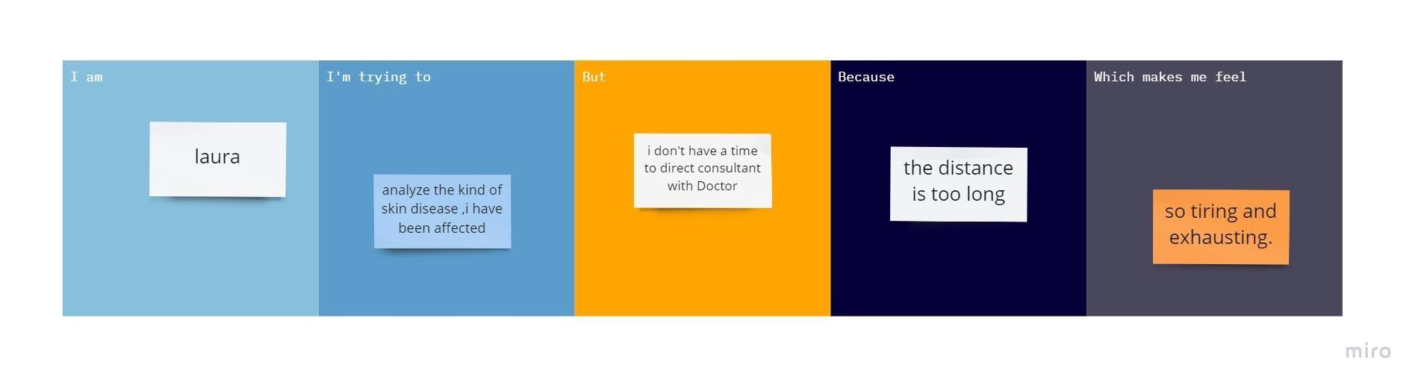

A problem statement is important to a process improvement project because it helps clearly identify the goals of the project and outline the scope of a project.

**How to write problem statement?**

A good problem statement can be created by identifying and answering several questions related to the problem,

* Identify the Problem
* Begin were statement with were ideal situation
* Describe current gaps
* State the consequence of the problem
* Propose addressing the problem

**3.****IDEATION AND PROPOSED SOLUTION**

**3.1 EMPATHY MAP CANVAS**

An empathy map canvas is a more in-depth version of the original empathy map, which helps identify and describe the user’s needs and pain points. And this is valuable information for improving the user experience.

Teams rely on user insights to map out what is important to their target audience, what influences them, and how they present themselves. This information is then used to create personas that help teams visualize users and empathize with them as individuals, rather than just as a vague marketing demographic or account number.

**Uses of empathy map canvas:**

An empathy map canvas helps brands provide a better experience for users by helping teams understand the perspectives and mindsets of their customers.

Using a template to create an empathy map canvas reduces the preparation time and standardizes the process so we create empathy map canvases of similar quality.

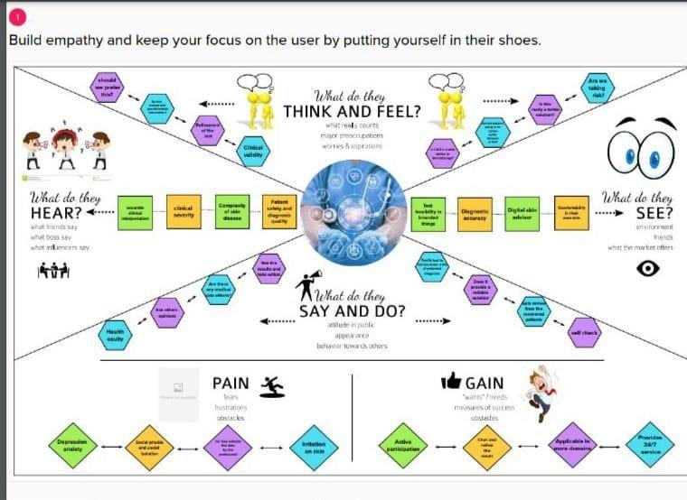

**How to create an empathy map canvas?**

Empathy maps are divided into segments, which are typically defined by questions that teams work to answered one by one to complete the map. Using MURAL’s template allows we to add color-coded sticky notes to help categorize answers visually.

**What do users say and do?**

* Answers to this question should come from interviews with customers, survey responses, or any other channel that provides direct feedback from customers.
* Try to include direct quotes from users in this section, such as, “I love this product; it saves me so much time every week.”
* These objective metrics can help we measure and track improvements over time.

**What do users think and feel?**

* Brainstorm and identify user goals for the product.
* Consider any fears that might present a hurdle to the sales team, like if they worry about difficult-to-navigate interfaces that slow them down or make their job impossible.
* Understanding these nuances helps teams identify which features that users prioritize, which allows them to ensure what they offer aligns with users’ needs.

**What do users see and hear?**

* To answer these questions, think about the person’s environment and the outside influences that surround them, including friends, colleagues, and media outlets. • For example, their friends might discuss products they use at work or read an industry publication that ranks best-in-class productivity tools
* It’s also important to ask what a customer stands to gain from using the product. Determine what pain points it solves by asking questions like.

### 3.2 IDEATION AND BRAIN STROMING

* Brainstorming provides a free and open environment that encourages everyone within a team to participate in the creative thinking process that leads to problem-solving.
* Prioritizing volume over value, out-of-the-box ideas are welcome and built upon, and all participants are encouraged to collaborate, helping each other develop a rich number of creative solutions.
* Use this template in were brainstorming sessions so were team can unleash their imagination and start shaping concepts even if we’re not sitting in the same room.

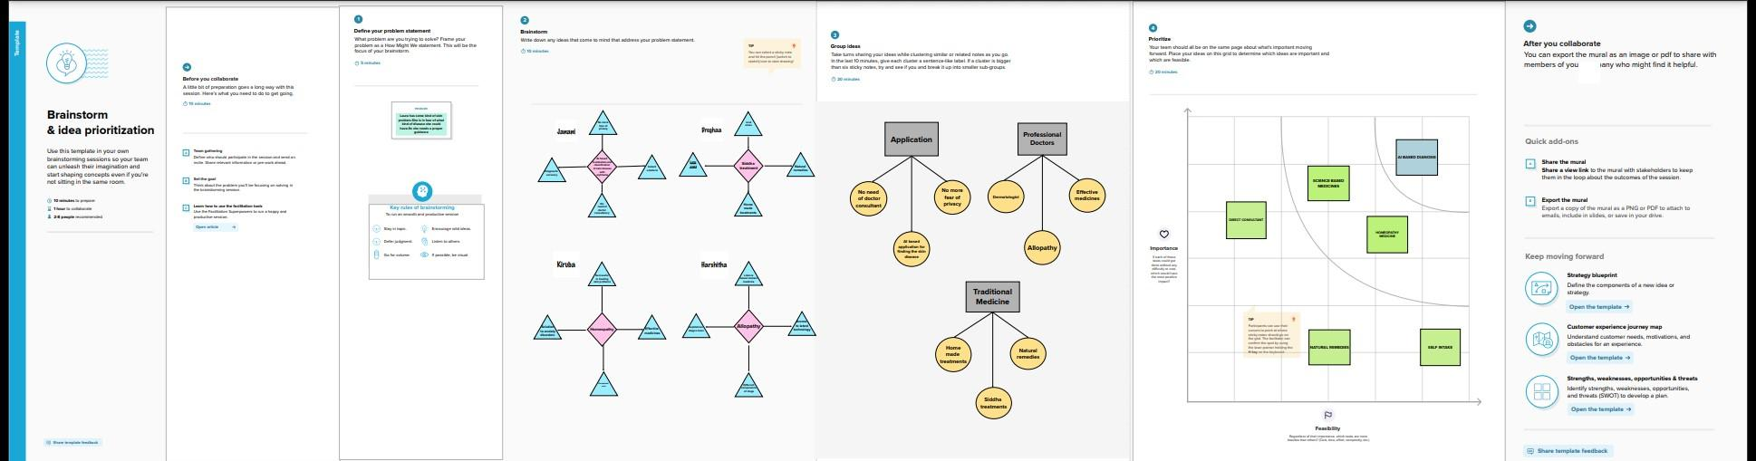

**3.3 PROPOSED SOLUTION**

The main goal of presenting a proposed solution is to provide a solution to a problem faced by a patient. This section should be as comprehensive as possible, and able to address all the needs that we have pointed out in the first section.

| **S.No.** | **Parameter** | **Description** |
| --- | --- | --- |
| 1. | Problem Statement (Problem to be solved) | Analysing the skin disease is difficult for many people because of the distance and time consumption of the direct consultant of doctors. |
| 2. | Idea / Solution description | Analysis of skin disease with automated screening and classification using neural network model. Three module is used in this app.They are 1.user module  2.segmentation module  3.notification module |
| 3. | Novelty / Uniqueness | * Accuracy of the results * Instant solutions |
| 4. | Social Impact / Customer Satisfaction | * No need of doctor consultancy * no more fear of privacy |
| 5. | Business Model (Revenue Model) | User module, segmentation module and notification module are used to get the desired results .android application is developed. |
| 6. | Scalability of the Solution | Most appropriate results are notified.  Time and cost consumption is achieved. |

#### 3.4 PROBLEM SOLUTION FIT

The Problem-Solution Fit canvas is based on the principles of Lean Startup, LUM (Lazy User Model) and User Experience . It helps to identify behavioral patterns.

* It is a template to help identify solutions with higher chances of solution adoption, reduce time spent on testing and get a better overview of the current situation.
* With this template we will be able to take important information into consideration at an earlier stage and look at problem solving in depth.

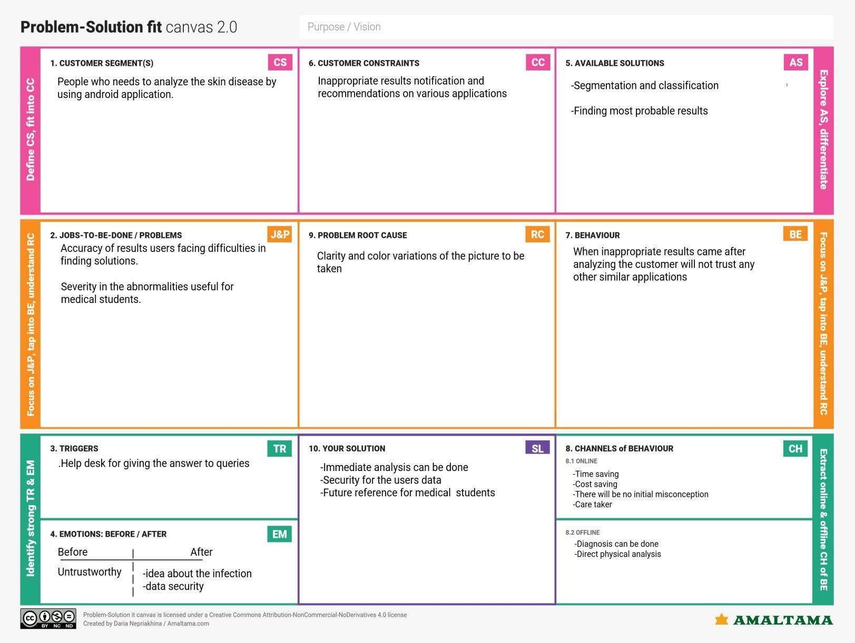

**4.REQUIREMENT ANALYSIS**

**4.1FUNCTIONAL REQUIREMENTS:**

Following are the functional requirements of the proposed solution.

| **FR No.** | **Functional**  **Requirement (Epic)** | **Sub Requirement (Story / Sub-Task)** |
| --- | --- | --- |
| FR-1 | User Registration | Registration through Form Registration through Gmail |
| FR-2 | User Confirmation | Confirmation via Email Confirmation via OTP |
| FR-3 | User verification | Verification using phone number |
| FR-4 | User login | Login using email and password |
| FR-5 | Pre medical history | User’s medical history collected via form |
| FR-6 | Upload pictures | Uploading affected area pictures through camera and jpg image format |

**4.2 NON-FUNCTIONAL REQUIREMENTS:**

Following are the non-functional requirements of the proposed solution.

| **FR No.** | **Non-Functional Requirement** | **Description** |
| --- | --- | --- |
| NFR-1 | **Usability** | Interface is user friendly and can be easily learned in simple trial of the application |
| NFR-2 | **Security** | All the data inside the system or its part will be  protected against malware attacks or unauthorized access |
| NFR-3 | **Reliability** | It performs the function consistently without any interruption by using neural network mod0el |
| NFR-4 | **Performance** | Analysis of the skin disease can be done accurately, so that it meets the user requirements |
| NFR-5 | **Availability** | An android application can be easily available to all the users |
| NFR-6 | **Scalability** | Updation can be made in future if needed . There will be the increase in performance of the application |

# 5.PROJECT DESIGN

**5.1 DATA FLOW DIAGRAM:**

A Data Flow Diagram (DFD) is a traditional visual representation of the information flows within a system. A neat and clear DFD can depict the right amount of the system requirement graphically. It shows how data enters and leaves the system, what changes the information, and where data is store.

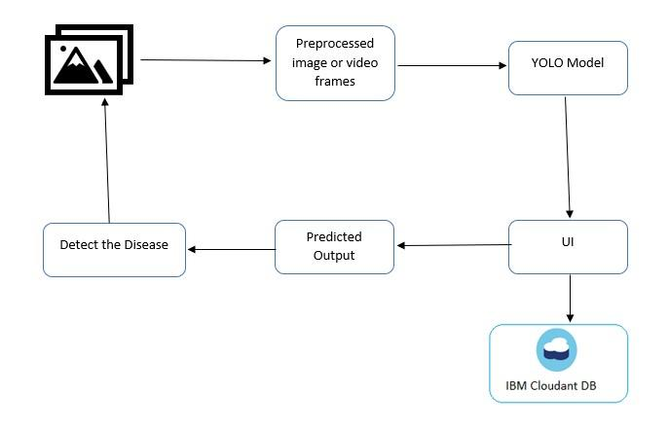

* Upload the affected skin image
* Image is processed by using yolo model
* By User login to the application
* Using the dermdata in the IBM cloudant DB it predict the output
* Detection of skin disease
* Notification is displayed to the user

**DATA FLOW DIAGRAM FOR DETECTION OF SKIN DISEASE**

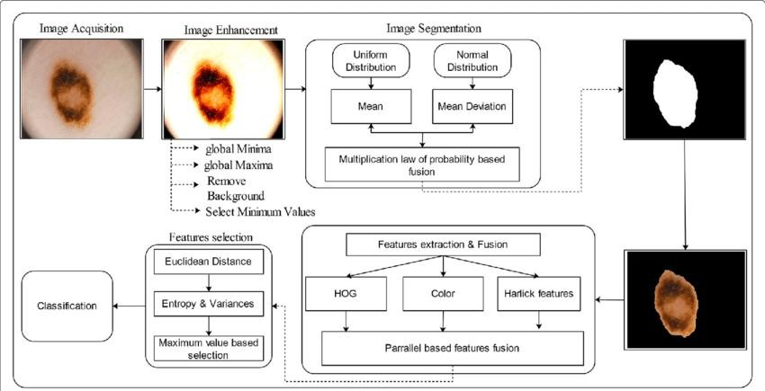

* 1. **SOLUTION AND TECHNICAL ARCHITECTURE**

**TECHNICAL ARCHITECTURE:**

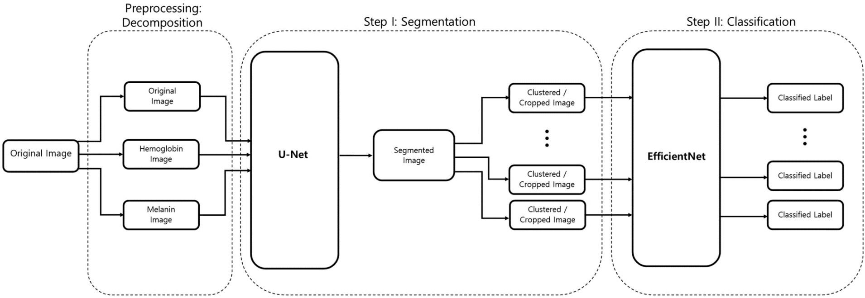

**TABLE 1 - COMPONENTS & TECHNOLOGIES:**

| **S.No** | **Component** | **Description** | **Technology** |
| --- | --- | --- | --- |
| 1. | User Interface | How user interacts with application e.g.  Web UI, Mobile App, Chatbot etc. | HTML, CSS, JavaScript / Angular Js / React Js etc. |
| 2. | Application Logic-1 | Logic for a process in the application | Java / Python |
| 3. | Application Logic-2 | Logic for a process in the application | IBM Watson STT service |
| 4. | Application Logic-3 | Logic for a process in the application | IBM Watson Assistant |
| 5. | Database | Data Type, Configurations etc. | MySQL, NoSQL, etc. |
| 6. | Cloud Database | Database Service on Cloud | IBM DB2, IBM Cloudant etc. |
| 7. | File Storage | File storage requirements | IBM Block Storage or Other  Storage Service or Local  Filesystem |
| 8. | External API-1 | Purpose of External API used in the application | IBM Weather API, etc. |
| 9. | External API-2 | Purpose of External API used in the application | Aadhar API, etc. |
| 10. | Machine Learning Model | Purpose of Machine Learning Model | Object Recognition Model, etc. |
| 11. | Infrastructure (Server / Cloud) | Application Deployment on Local  System / Cloud  Local Server Configuration:  Cloud Server Configuration : | Local, Cloud Foundry, Kubernetes, etc. |

**TABLE 2 - APPLICATION CHARACTERISTICS:**

| **S.No** | **Characteristics** | **Description** | **Technology** |
| --- | --- | --- | --- |
| 1. | Open-Source Frameworks | List the open-source frameworks used | Technology of Opensource framework |
| 2. | Security Implementations | List all the security / access controls implemented, use of firewalls etc. | e.g. SHA-256, Encryptions, IAM Controls, OWASP etc. |
| 3. | Scalable Architecture | Justify the scalability of architecture (3 – tier, Micro-services) | Technology used |
| 4. | Availability | Justify the availability of application  (e.g. use of load balancers, distributed servers etc.) | Technology used |
| 5. | Performance | Design consideration for the performance of the application (number of requests per sec, use of Cache, use of CDN’s) etc. | Technology used |

| **User Type** | **Functional**  **Requirement (Epic)** | **User**  **Story**  **Number** | **User Story / Task** | **Acceptance criteria** | **Priority** |
| --- | --- | --- | --- | --- | --- |
| Customer (Mobile user) | Registration | USN-1 | As a user, I can register for the application by entering my email, password, and confirming my password. | I can access my account / dashboard | High |
|  |  | USN-2 | As a user, I will receive confirmation email once I have registered for the application | I can receive confirmation email & click confirm | High |
|  |  | USN-3 | As a user, I can register for the application through Facebook | I can register & access the dashboard with Facebook Login | Low |
|  |  | USN-4 | As a user, I can register for the application through Gmail | I can submit the application form | Medium |
|  | Login | USN-5 | As a user, I can log into the application by entering email & password | I can able to login by clicking login | High |
|  | Dashboard | USN-6 | As a user , I can see many options given in the dashboard | I can go to any option by clicking those option | High |
| Customer (Web user) | Registration | USN-7 | As a user, I can register for the application by entering my email, password, and confirming my password. | I can access my account / dashboard | High |
|  |  | USN-8 | As a user, I will receive confirmation email once I have registered for the application | I can receive confirmation email & click confirm | High |

**6. PROJECT PLANNING AND SCHEDULING**

**6.1 SPRINT PLANNING AND ESTIMATION:**

**INTRODUCTION:**

Erythema is a broad category of skin condition that can impact any area of the skin and mucous membranes. It usually occurs in response to disease or infection in reaction to a drug. Severity of the rash ranges from mild to life threatening. What Is Erythema? Erythema is an abnormal redness of skin or mucous membranes. Capillary congestion causes the condition, and red splotches on the hands or feet are classic examples of it. People often mistake erythema for common skin inflammation or psoriasis because it has similar characteristics: redness, rashes, swelling and skin sensitivity.

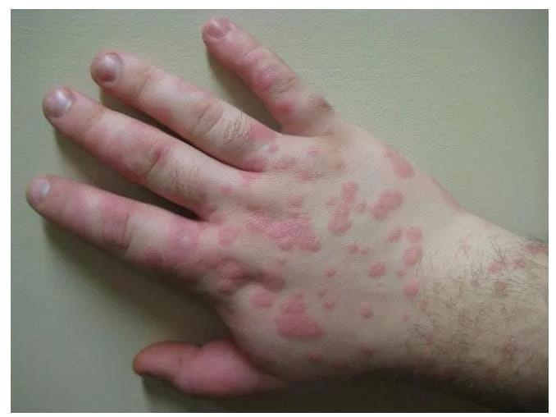

**Erythema Multiforme:**

Erythema multiforme (EM) is the most common type of erythema. Its cause is thought to be IgM immune complexes deposited in the skin, often as a result of viral or bacterial infections, such as herpes simplex virus (HSV) type 1 and 2 and Mycoplasma pneumoniae infections. More rarely, it can be a reaction to a drug or vaccine, according to the National Library of Medicine.

The condition can affect both men and women, although men are five times more likely to develop it compared to women. Most people who get EM are between 20 and 30 years old, although 20% of those diagnosed are children.

**Types:**

There are two types of EM, minor and major.

Erythema multiforme minor (EM minor) typically occurs on the peripheral parts of the body, such as the fingers and toes. Rarely, it may manifest as light mouth sores. It usually clears up on its own.

Erythema multiforme major (EM major) skin lesions are more extensive and serious. Raised, edematous papules covering more than 10% of the body with involvement of at least one mucous membrane characterizes the condition. A drug reaction is a more likely cause than an infection. Similarly, medication also causes Stevens-Johnson Syndrome, a potentially life-threatening skin rash.

Unlike EM minor, EM major causes extensive blistering sores on one or more of the body’s mucous membranes, such as the lips or mouth.. They can also appear on the eyes or anus. If you are experiencing irritation or what appears to be blistering on one of these areas of your body.

**Symptoms:**

Most people with EM develop a sudden small rash that usually begins on their feet or hands and spreads to the upper limbs, face and upper body. It starts with small red spots that grow larger and form what looks to be a bull’s-eye, darker in the middle with a lighter outer ring.

**EM symptoms include:**

* Circular red bumps on the soles, palms, arms, face and legs that grow into circles that may look like targets.
* Itchiness, in some cases.
* Painful sores or blisters on the lips, mouth, eyes and genitals.
* Red patches with pale rings inside the patch with purple centers and small blisters, called target lesions.
* Fever.
* Joint pain.
* Sensitivity to light.

**First Stage Plan:**

It is the phase when erythema can be seen within a few hours of irradiation (although it is extremely rare with radiological interventional procedures). This early phase of erythema is generally transient, subsiding after 24 - 48 hours, but it may persist and evolve, ‘blending’ with the subsequent phases. Whether or not those early changes are of importance and influence the subsequent course of the skin reaction remains a matter of debate. However, it is generally considered that early erythema does not necessarily predict a particular severity of the later phases.

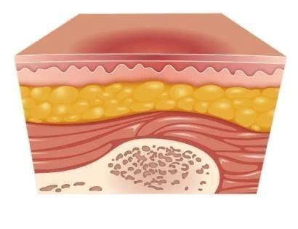

**Second Stage Plan:**

This corresponds clinically to a more severe reddening of the skin, and is usually associated with inflammatory reactions. It starts about two to three weeks after exposure. It may be painful (as a burn). Within a short time it may become associated with various degrees of skin desquamation, and possibly with pigmentation. Skin lesions that up to now were not very painful can become painful at this stage. These pains can be very severe when the irradiated volume was large. An important point here is that moist desquamation, which implies a total destruction of the epidermis, is a clear predictor of late delayed injuries, particularly telangiectasias.

The early phase of erythema is usually not detectable in dark skinned people; in the second "main" phase, it is generally hyperpigmentation that is observed.

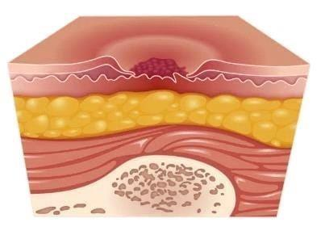

**Third Stage Plan:**

Classically, a third phase of erythema can be observed later, between 8 to 20 weeks after irradiation. This phase is associated with dermal ischemia and may also evolve towards necrosis.

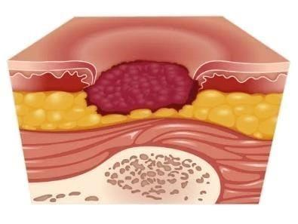

**Fourth Stage Plan:**

Evolution: If severe, skin reactions can be responsible for late radiodermatitis. Increased pigmentation is usual, but depigmentation can also be observed (usually at higher doses), with a combination of both being observed in some cases. The skin may also become hyperkeratotic.

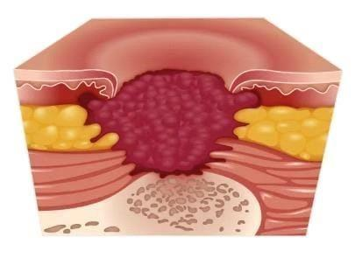

**Fifth Stage Plan:**

Reactivation: As could be expected, sunburn is likely to exacerbate any radiation induced erythema reaction. A few drugs are also capable of increasing erythema linked to radiation exposure; this is particularly true for some antineoplastic agents, such as Bleomycin, Adriamycin and the Taxanes drugs. Interestingly, after erythema subsides, it can be reactivated (i.e re-appearance of erythema in the same area) if the drug is given a few days or weeks later.



**TREATMENT:**

The treatment for erythema multiforme depends on the subtype. EM minor usually goes away on its own, but if symptoms persist, a doctor might recommend topical steroids. If EM minor symptoms recur because of a suspected herpes flare-up, doctors may prescribe antiviral medications such as acyclovir or valacyclovir.

The presence of EM can also be a sign of a more serious condition or a compromise of the immune system. When your doctor examines you, they may choose to recommend additional testing.

## 6.2 SPRINT DELIVERY SCHEDULE

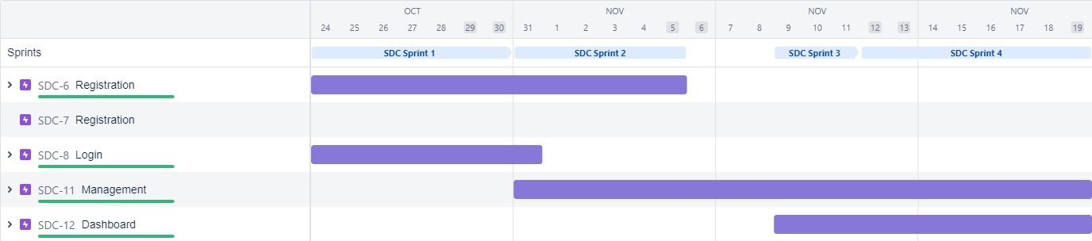

## 

## 7. CODING AND SOLUTIONING

**7.1 FEATURE 1:**

**Index.html :**

**<!DOCTYPE html>**

**<html lang="en">**

**<head>**

**<meta charset="UTF-8" />**

**<meta http-equiv="X-UA-Compatible" content="IE=edge" />**

**<meta name="viewport" content="width=device-width, initial-scale=1.0" />**

**<!-- CSS only -->**

**<link**

**href="https://cdn.jsdelivr.net/npm/bootstrap@5.2.2/dist/css/bootstrap.min.css"**

**rel="stylesheet"**

**integrity="sha384-Zenh87qX5JnK2Jl0vWa8Ck2rdkQ2Bzep5IDxbcnCeuOxjzrPF/et3URy9Bv1WTRi"**

**crossorigin="anonymous"**

**/>**

**<title>Home</title>**

**</head>**

**<body>**

**<nav class="navbar navbar-expand-lg navbar-dark bg-dark">**

**<div class="container-fluid">**

**<div></div>**

**<div class="collapse navbar-collapse d-flex" id="navbarScroll">**

**<ul**

**class="navbar-nav me-auto my-2 my-lg-0 navbar-nav-scroll"**

**style="--bs-scroll-height: 100px"**

**>**

**<li class="nav-item">**

**<a class="nav-link active" aria-current="page" href="/">Skinnovation</a>**

**</li>**

**</ul>**

**<div class="d-flex" role="search">**

**<ul**

**class="navbar-nav me-auto my-2 my-lg-0 navbar-nav-scroll"**

**style="--bs-scroll-height: 100px"**

**>**

**<li class="nav-item">**

**<a class="nav-link active" aria-current="page" href="/">Home</a>**

**</li>**

**<li class="nav-item">**

**<a class="nav-link" href="/login">login</a>**

**</li>**

**<li class="nav-item">**

**<a class="nav-link" href="/register">Register</a>**

**</li>**

**<li class="nav-item">**

**<a class="nav-link" href="/prediction">Prediction</a>**

**</li>**

**</ul>**

**</div>**

**</div>**

**</div>**

**</nav>**

**<img src="/static/skin-problem.jpg" height="1200" width="1500" alt="Skin Disease" srcset="" />**

**<p style="font-family:tahoma;">**

**Now a day’s people are suffering from skin diseases, More than 125 million people suffering from Psoriasis also skin cancer rate is rapidly increasing over the last few decades especially Melanoma is most diversifying skin cancer. If skin diseases are not treated at an earlier stage, then it may lead to complications in the body including spreading of the infection from one individual to the other. The skin diseases can be prevented by investigating the infected region at an early stage. The characteristic of the skin images is diversified so that it is a challenging job to devise an efficient and robust algorithm for automatic detection of skin disease and its severity. Skin tone and skin colour play an important role in skin disease detection. Colour and coarseness of skin are visually different. Automatic processing of such images for skin analysis requires quantitative discriminator to differentiate the diseases.**

**To overcome the above problem we are building a model which is used for the prevention and early detection of skin cancer, psoriasis. Basically, skin disease diagnosis depends on the different characteristics like colour, shape, texture etc. Here the person can capture the images of skin and then the image will be sent the trained model. The model analyses the image and detect whether the person is having skin disease or not.</p>**

**<h1 class="head">Proposed Solution</h1>**

**<p style="font-family:tahoma;">**

**Different skin disorders can be detected by just**

**submitting photographs, and this approach is**

**quite effective at helping people in the**

**community identify ailments earlier.**

**Our return on investment will be the creation**

**and distribution of a proprietary product that**

**will be used as a solution.**

**This system is more scalable because it accepts**

**any picture type, regardless of resolution, and**

**offers good performance in any situation.**

**</p></div>**

**</body>**

**<!-- JavaScript Bundle with Popper -->**

**<script**

**src="https://cdn.jsdelivr.net/npm/bootstrap@5.2.2/dist/js/bootstrap.bundle.min.js"**

**integrity="sha384-OERcA2EqjJCMA+/3y+gxIOqMEjwtxJY7qPCqsdltbNJuaOe923+mo//f6V8Qbsw3"**

**crossorigin="anonymous"**

**></script>**

**</html>**

**Login.html**

**<!DOCTYPE html>**

**<html lang="en">**

**<head>**

**<meta charset="UTF-8" />**

**<meta http-equiv="X-UA-Compatible" content="IE=edge" />**

**<meta name="viewport" content="width=device-width, initial-scale=1.0" />**

**<title>Login</title>**

**<link**

**href="https://cdn.jsdelivr.net/npm/bootstrap@5.2.2/dist/css/bootstrap.min.css"**

**rel="stylesheet"**

**integrity="sha384-Zenh87qX5JnK2Jl0vWa8Ck2rdkQ2Bzep5IDxbcnCeuOxjzrPF/et3URy9Bv1WTRi"**

**crossorigin="anonymous"**

**/>**

**</head>**

**<style>**

**.wrapper {**

**margin-top: 80px;**

**margin-bottom: 80px;**

**}**

**.form-signin {**

**max-width: 380px;**

**padding: 15px 35px 45px;**

**margin: 0 auto;**

**background-color: #fff;**

**border: 1px solid rgba(0, 0, 0, 0.1);**

**}**

**.form-signin .form-signin-heading,**

**.form-signin .checkbox {**

**margin-bottom: 30px;**

**}**

**.form-signin .checkbox {**

**font-weight: normal;**

**}**

**.form-signin .form-control {**

**position: relative;**

**font-size: 16px;**

**height: auto;**

**padding: 10px;**

**-webkit-box-sizing: border-box;**

**-moz-box-sizing: border-box;**

**box-sizing: border-box;**

**}**

**.form-signin .form-control:focus {**

**z-index: 2;**

**}**

**.form-signin input[type="text"] {**

**margin-bottom: -1px;**

**border-bottom-left-radius: 0;**

**border-bottom-right-radius: 0;**

**}**

**.form-signin input[type="password"] {**

**margin-bottom: 20px;**

**border-top-left-radius: 0;**

**border-top-right-radius: 0;**

**}**

**</style>**

**<body>**

**<nav class="navbar navbar-expand-lg navbar-dark bg-dark">**

**<div class="container-fluid">**

**<div></div>**

**<div class="collapse navbar-collapse d-flex" id="navbarScroll">**

**<ul**

**class="navbar-nav me-auto my-2 my-lg-0 navbar-nav-scroll"**

**style="--bs-scroll-height: 100px"**

**>**

**<li class="nav-item">**

**<a class="nav-link active" aria-current="page" href="/"**

**>Skinnovation</a**

**>**

**</li>**

**</ul>**

**<div class="d-flex" role="search">**

**<ul**

**class="navbar-nav me-auto my-2 my-lg-0 navbar-nav-scroll"**

**style="--bs-scroll-height: 100px"**

**>**

**<li class="nav-item">**

**<a class="nav-link" aria-current="page" href="/">Home</a>**

**</li>**

**<li class="nav-item">**

**<a class="nav-link active" href="/login">login</a>**

**</li>**

**<li class="nav-item">**

**<a class="nav-link" href="/register">Register</a>**

**</li>**

**<li class="nav-item">**

**<a class="nav-link" href="/prediction">Prediction</a>**

**</li>**

**</ul>**

**</div>**

**</div>**

**</div>**

**</nav>**

**<div class="wrapper">**

**<form class="form-signin" method="POST">**

**<h2 class="form-signin-heading text-center">Please login</h2>**

**<input**

**type="text"**

**class="form-control"**

**name="username"**

**placeholder="Email Address"**

**required=""**

**autofocus=""**

**/>**

**<input**

**type="password"**

**class="form-control"**

**name="password"**

**placeholder="Password"**

**required=""**

**/>**

**<div class="text-center">**

**<button class="btn btn-lg btn-primary btn-block" type="submit">**

**Login**

**</button>**

**</div>**

**<div>**

**<a href="/register">Don't have account ? </a>**

**</div>**

**</form>**

**</div>**

**</body>**

**<script**

**src="https://cdn.jsdelivr.net/npm/bootstrap@5.2.2/dist/js/bootstrap.bundle.min.js"**

**integrity="sha384-OERcA2EqjJCMA+/3y+gxIOqMEjwtxJY7qPCqsdltbNJuaOe923+mo//f6V8Qbsw3"**

**crossorigin="anonymous"**

**></script>**

**</html>**

**Logout.html**

**<!DOCTYPE html>**

**<html lang="en">**

**<head>**

**<meta charset="UTF-8" />**

**<meta http-equiv="X-UA-Compatible" content="IE=edge" />**

**<meta name="viewport" content="width=device-width, initial-scale=1.0" />**

**<title>Logout</title>**

**<link**

**href="https://cdn.jsdelivr.net/npm/bootstrap@5.2.2/dist/css/bootstrap.min.css"**

**rel="stylesheet"**

**integrity="sha384-Zenh87qX5JnK2Jl0vWa8Ck2rdkQ2Bzep5IDxbcnCeuOxjzrPF/et3URy9Bv1WTRi"**

**crossorigin="anonymous"**

**/>**

**</head>**

**<body>**

**<nav class="navbar navbar-expand-lg navbar-dark bg-dark">**

**<div class="container-fluid">**

**<div></div>**

**<div class="collapse navbar-collapse d-flex" id="navbarScroll">**

**<ul**

**class="navbar-nav me-auto my-2 my-lg-0 navbar-nav-scroll"**

**style="--bs-scroll-height: 100px"**

**>**

**<li class="nav-item">**

**<a class="nav-link active" aria-current="page" href="/"**

**>Skinnovation</a**

**>**

**</li>**

**</ul>**

**<div class="d-flex" role="search">**

**<ul**

**class="navbar-nav me-auto my-2 my-lg-0 navbar-nav-scroll"**

**style="--bs-scroll-height: 100px"**

**>**

**<li class="nav-item">**

**<a class="nav-link" aria-current="page" href="/">Home</a>**

**</li>**

**<li class="nav-item">**

**<a class="nav-link active" href="/login">login</a>**

**</li>**

**<li class="nav-item">**

**<a class="nav-link" href="/register">Register</a>**

**</li>**

**<li class="nav-item">**

**<a class="nav-link" href="/prediction">Prediction</a>**

**</li>**

**</ul>**

**</div>**

**</div>**

**</div>**

**</nav>**

**<div class="row">**

**<div class="col text-center">**

**<h3>Successfully logged out</h3>**

**<a class="btn btn-dark" href="/login" > login </a>**

**</div>**

**</div>**

**</body>**

**<script**

**src="https://cdn.jsdelivr.net/npm/bootstrap@5.2.2/dist/js/bootstrap.bundle.min.js"**

**integrity="sha384-OERcA2EqjJCMA+/3y+gxIOqMEjwtxJY7qPCqsdltbNJuaOe923+mo//f6V8Qbsw3"**

**crossorigin="anonymous"**

**></script>**

**</html>**

## prediction.html

<!DOCTYPE html>

<html lang="en">

<head>

<meta charset="UTF-8">

<meta http-equiv="X-UA-Compatible" content="IE=edge">

<meta name="viewport" content="width=device-width, initial-scale=1.0">

<title>Prediction</title>

<link

href="https://cdn.jsdelivr.net/npm/bootstrap@5.2.2/dist/css/bootstrap.min.css"

rel="stylesheet"

integrity="sha384-Zenh87qX5JnK2Jl0vWa8Ck2rdkQ2Bzep5IDxbcnCeuOxjzrPF/et3URy9Bv1WTRi"

crossorigin="anonymous"

/>

</head>

<body>

<nav class="navbar navbar-expand-lg navbar-dark bg-dark">

<div class="container-fluid">

<div></div>

<div class="collapse navbar-collapse d-flex" id="navbarScroll">

<ul

class="navbar-nav me-auto my-2 my-lg-0 navbar-nav-scroll"

style="--bs-scroll-height: 100px"

>

<li class="nav-item">

<a class="nav-link active" aria-current="page" href="/">Skinnovation</a>

</li>

</ul>

<div class="d-flex" role="search">

<ul

class="navbar-nav me-auto my-2 my-lg-0 navbar-nav-scroll"

style="--bs-scroll-height: 100px"

>

<li class="nav-item">

<a class="nav-link " aria-current="page" href="/">Home</a>

</li>

<li class="nav-item">

<a class="nav-link" href="/login">login</a>

</li>

<li class="nav-item">

<a class="nav-link" href="/register">Register</a>

</li>

<li class="nav-item">

<a class="nav-link active" href="/prediction">Prediction</a>

</li>

</ul>

</div>

</div>

</div>

</nav>

<div class="row">

<div class="col">

<br><br>

<h2 class="title text-muted text-center p-4" >SKINALYTICS- AI-based localization and classification of skin disease with erythema</h1>

<div class="line" style="width: 1000px;"></div>

</div>

</div>

<div class="row p-4 ">

<div class="col-4">

Nowadays people are suffering from skin diseases, More than 125 million people suffering from Psoriasis also skin cancer rate is rapidly increasing over the last few decades especially Melanoma is most diversifying skin cancer. If skin diseases are not treated at an earlier stage, then it may lead to complications in the body including spreading of the infection from one individual to the other. The skin diseases can be prevented by investigating the infected region at an early stage. The characteristic of the skin images is diversified so that it is a challenging job to devise an efficient and robust algorithm for automatic detection of skin disease and its severity. Skin tone and skin colour play an important role in skin disease detection. Colour and coarseness of skin are visually different. Automatic processing of such images for skin analysis requires quantitative discriminator to differentiate the diseases.

</div>

<div class="col">

<div class="prediction-input text-center">

<img class="d-block" src="https://img.graphicsurf.com/2020/06/Woman-in-a-protective-mask-against-the-virus-concept.jpg" alt="Second slide" style="width:80%!important; align:center; padding-left:100px">

</br>

<form id="form" action="/prediction" method="post" enctype="multipart/form-data">

<a type="submit" class="btn btn-primary" > Click Me! For a Demo </a>

</form>

</div>

<h5 style="text-color:Red;" > </h5>

<b style="text-color:Red">{{prediction}}<b>

</h5>

</div>

</div>

</div>

</body>

<script

src="https://cdn.jsdelivr.net/npm/bootstrap@5.2.2/dist/js/bootstrap.bundle.min.js"

integrity="sha384-OERcA2EqjJCMA+/3y+gxIOqMEjwtxJY7qPCqsdltbNJuaOe923+mo//f6V8Qbsw3"

crossorigin="anonymous"

></script>

</html>

## register.html

<!DOCTYPE html>

<html lang="en">

<head>

<meta charset="UTF-8" />

<meta http-equiv="X-UA-Compatible" content="IE=edge" />

<meta name="viewport" content="width=device-width, initial-scale=1.0" />

<title>Register</title>

</head>

<link

href="https://cdn.jsdelivr.net/npm/bootstrap@5.2.2/dist/css/bootstrap.min.css"

rel="stylesheet"

integrity="sha384-Zenh87qX5JnK2Jl0vWa8Ck2rdkQ2Bzep5IDxbcnCeuOxjzrPF/et3URy9Bv1WTRi"

crossorigin="anonymous"

/>

<style>

.wrapper {

margin-top: 80px;

margin-bottom: 80px;

}

.form-signin {

max-width: 380px;

padding: 15px 35px 45px;

margin: 0 auto;

background-color: #fff;

border: 1px solid rgba(0, 0, 0, 0.1);

}

.form-signin .form-signin-heading,

.form-signin .checkbox {

margin-bottom: 30px;

}

.form-signin .checkbox {

font-weight: normal;

}

.form-signin .form-control {

position: relative;

font-size: 16px;

height: auto;

padding: 10px;

-webkit-box-sizing: border-box;

-moz-box-sizing: border-box;

box-sizing: border-box;

}

.form-signin .form-control:focus {

z-index: 2;

}

.form-signin input[type="text"] {

margin-bottom: -1px;

border-bottom-left-radius: 0;

border-bottom-right-radius: 0;

}

.form-signin input[type="password"] {

margin-bottom: 20px;

border-top-left-radius: 0;

border-top-right-radius: 0;

}

</style>

<body>

<nav class="navbar navbar-expand-lg navbar-dark bg-dark">

<div class="container-fluid">

<div></div>

<div class="collapse navbar-collapse d-flex" id="navbarScroll">

<ul

class="navbar-nav me-auto my-2 my-lg-0 navbar-nav-scroll"

style="--bs-scroll-height: 100px"

>

<li class="nav-item">

<a class="nav-link active" aria-current="page" href="/"

>Skinnovation</a

>

</li>

</ul>

<div class="d-flex" role="search">

<ul

class="navbar-nav me-auto my-2 my-lg-0 navbar-nav-scroll"

style="--bs-scroll-height: 100px"

>

<li class="nav-item">

<a class="nav-link" aria-current="page" href="/">Home</a>

</li>

<li class="nav-item">

<a class="nav-link" href="/login">login</a>

</li>

<li class="nav-item">

<a class="nav-link active" href="/register">Register</a>

</li>

<li class="nav-item">

<a class="nav-link" href="/prediction">Prediction</a>

</li>

</ul>

</div>

</div>

</div>

</nav>

<div class="wrapper">

<form class="form-signin" method="POST">

<h2 class="form-signin-heading text-center">Register Here</h2>

<input

type="text"

class="form-control"

name="username"

placeholder="Username"

required

autofocus=""

/>

<input

type="email"

class="form-control"

name="email"

placeholder="Email Address"

required

autofocus=""

/>

<input

type="password"

class="form-control"

name="password"

placeholder="Password"

required

/>

<div class="text-center">

<button class="btn btn-lg btn-primary btn-block" type="submit">

Register

</button>

</div>

<br>

<div>

<a href="/login">Already have account. </a>

</div>

</form>

</div>

</body>

<script

src="https://cdn.jsdelivr.net/npm/bootstrap@5.2.2/dist/js/bootstrap.bundle.min.js"

integrity="sha384-OERcA2EqjJCMA+/3y+gxIOqMEjwtxJY7qPCqsdltbNJuaOe923+mo//f6V8Qbsw3"

crossorigin="anonymous"

></script>

</html>

**7.2 FEATURE 2**

# -*- coding: utf-8 -*- """Untitled0.ipynb

Automatically generated by Colaboratory.

Original file is located at

https://colab.research.google.com/drive/1PYFZ7zKhWpFF5YilnguhZ8X1EgtSIJN4 """

import re import numpy as np

import os

from flask import Flask, app,request,render_template import sys

from flask import Flask, request, render_template, redirect, url_for import argparse from tensorflow import keras from PIL import Image

from timeit import default_timer as timer import test

from pyngrok import ngrok import pandas as pd import numpy as np

import random

def get_parent_dir(n=1):

""" returns the n-th parent dicrectory of the current working directory """ current_path = os.path.dirname(os.path.abspath(__file__)) for k in range(n): current_path = os.path.dirname(current_path) return current_path

src_path=r'/content/drive/MyDrive/IBM_PROJECT/yolo_structure/2_Training/src' print(src_path)

utils_path=r'/content/drive/MyDrive/IBM_PROJECT/yolo_structure/Utils' print(utils_path)

sys.path.append(src_path)

sys.path.append(utils_path)

import argparse

from keras_yolo3.yolo import YOLO, detect_video

from PIL import Image

from timeit import default_timer as timer

from utils import load_extractor_model, load_features, parse_input, detect_object import test import utils import pandas as pd import numpy as np

from Get_File_Paths import GetFileList import random

os.environ["TF_CPP_MIN_LOG_LEVEL"] = "3"

# Set up folder names for default values

data_folder = os.path.join(get_parent_dir(n=1), "yolo_structure", "Data")

image_folder = os.path.join(data_folder, "Source_Images")

image_test_folder = os.path.join(image_folder, "Test_Images")

detection_results_folder = os.path.join(image_folder, "Test_Image_Detection_Results") detection_results_file = os.path.join(detection_results_folder, "Detection_Results.csv")

model_folder = os.path.join(data_folder, "Model_Weights")

model_weights = os.path.join(model_folder, "trained_weights_final.h5") model_classes = os.path.join(model_folder, "data_classes.txt")

anchors_path = os.path.join(src_path, "keras_yolo3", "model_data", "yolo_anchors.txt")

FLAGS = None

from cloudant.client import Cloudant

# Authenticate using an IAM API key

client = Cloudant.iam('ef7f4729-2486-45c5-a7fa-f4140373e2e6-

bluemix','6GfFjs3engXLnSJB8Kp4fbs7HTKwrJpWJE7wNPGzZPVW', connect=True)

# Create a database using an initialized client my_database = client.create_database('my_database')

app=Flask(__name__) port_no=5000 ngrok.set_auth_token("2H7aM94zEuTa40t3J6jKpIqWAc3_B2UxzZs6qxetntgadxQW") public_url = ngrok.connect(port_no).public_url

print(f"To acces the Gloable link please click {public_url}")

#default home page or route

@app.route('/') def index(): return render_template('index.html')

@app.route('/index.html') def home(): return render_template("index.html")

#registration page @app.route('/register') def register(): return render_template('register.html')

@app.route('/afterreg', methods=['POST']) def afterreg(): x = [x for x in request.form.values()] print(x) data = {

'_id': x[1], # Setting _id is optional

'name': x[0],

'psw':x[2]

}

print(data)

query = {'_id': {'$eq': data['_id']}}

docs = my_database.get_query_result(query) print(docs)

print(len(docs.all()))

if(len(docs.all())==0):

url = my_database.create_document(data)

#response = requests.get(url)

return render_template('register.html', pred="Registration Successful, please login using your details") else:

return render_template('register.html', pred="You are already a member, please login using your details")

#login page @app.route('/login') def login(): return render_template('login.html')

@app.route('/afterlogin',methods=['POST']) def afterlogin(): user = request.form['_id'] passw = request.form['psw'] print(user,passw)

query = {'_id': {'$eq': user}}

docs = my_database.get_query_result(query) print(docs)

print(len(docs.all()))

if(len(docs.all())==0): return render_template('login.html', pred="The username is not found.") else: if((user==docs[0][0]['_id'] and passw==docs[0][0]['psw'])):

return redirect(url_for('prediction')) else:

print('Invalid User')

@app.route('/logout') def logout(): return render_template('logout.html')

@app.route('/prediction') def prediction(): return render_template('prediction.html',path="../static/img/6623.jpg",)

@app.route('/result',methods=["GET","POST"]) def res():

# Delete all default flags

parser = argparse.ArgumentParser(argument_default=argparse.SUPPRESS)

"""

Command line options

"""

f = request.files['file']

f.save("./drive/MyDrive/IBM_PROJECT/Flask/static/img/"+f.filename)

parser.add_argument( "--input_path", type=str,

default=image_test_folder,

help="Path to image/video directory. All subdirectories will be included. Default is " + image_test_folder,

)

parser.add_argument(

"--output", type=str,

default=detection_results_folder,

help="Output path for detection results. Default is " + detection_results_folder,

)

parser.add_argument( "--no_save_img", default=False, action="store_true",

help="Only save bounding box coordinates but do not save output images with annotated boxes. Default is False.",

)

parser.add_argument(

"--file_types", "--names-list", nargs="*", default=[],

help="Specify list of file types to include. Default is --file_types .jpg .jpeg .png .mp4",

)

parser.add_argument( "--yolo_model", type=str, dest="model_path", default=model_weights,

help="Path to pre-trained weight files. Default is " + model_weights,

)

parser.add_argument(

"--anchors",

type=str,

dest="anchors_path", default=anchors_path,

help="Path to YOLO anchors. Default is " + anchors_path,

)

parser.add_argument(

"--classes", type=str, dest="classes_path", default=model_classes,

help="Path to YOLO class specifications. Default is " + model_classes,

)

parser.add_argument(

"--gpu_num", type=int, default=1, help="Number of GPU to use. Default is 1"

)

parser.add_argument( "--confidence", type=float, dest="score", default=0.25,

help="Threshold for YOLO object confidence score to show predictions. Default is 0.25.",

)

parser.add_argument( "--box_file", type=str, dest="box",

default=detection_results_file,

help="File to save bounding box results to. Default is " + detection_results_file,

)

parser.add_argument(

"--postfix", type=str, dest="postfix", default="_disease",

help='Specify the postfix for images with bounding boxes. Default is "_disease"',

)

yolo = YOLO(

**{

"model_path": FLAGS.model_path,

"anchors_path": FLAGS.anchors_path,

"classes_path": FLAGS.classes_path,

"score": FLAGS.score,

"gpu_num": FLAGS.gpu_num,

"model_image_size": (416, 416),

}

)

img_path="/drive/MyDrive/IBM_PROJECT/Flask/static/img/"+f.filename prediction, image,lat,lon= detect_object( yolo, img_path,

save_img=save_img, save_img_path=FLAGS.output, postfix=FLAGS.postfix,

)

yolo.close_session() return

render_template('prediction.html',prediction=str(prediction),path="../static/img/"+f.filename)

""" Running our application """ if __name__ == "__main__":

app.run(port=port_no)

### 8. TESTING

**8.1 TEST CASES:**

A test case is a set of actions performed on a system to determine if it satisfies software requirements and functions correctly.

The purpose of a test case is to determine if different features within a system are performing as expected and to confirm that thesystem satisfies all related standards, guidelines and customer requirements.

The process of writing a test case can also help reveal errors or defects within the system.

Test cases are typically written by members of the quality assurance (QA) team or the testing team and can be used as step-by-step instructions for each system test.

|  |  |  | | Date | 18-Nov-22 |  |  | |  |  |  | |  |
| --- | --- | --- | --- | --- | --- | --- | --- | --- | --- | --- | --- | --- | --- |
| Team ID | PNT2022TMIDD08233 |
| Project Name | AI-based localization and classification of skin disease with erythema |
| Maximum Marks | 4 marks |
| **Test case ID** | **Feature Type** | **Component** | **Test Scenario** | **Pre-**  **Requisite** | **Steps**  **To Execut**  **e** | **Test Data** | **Expected Result** | **Actual Result** | **Status** | **Comments** | **TC for**  **Automation(Y/**  **N)** | **BUG**  **ID** | **Executed By** |
| HomePage_TC_  OO1 | Functional | Home Page | Verify user is able to see the home page or not. |  | 1. Enter URL and click go 2. verify whether the user is able to see the home page. | Enter URL and click go | User able to see the home page | Working as expected | Pass | Nil | N | _ | JANANI K |
| HomePage_TC_ OO2 | UI | Home Page | Verify the UI elements in  Home Page |  | 1. Enter URL and click go 2. Verify the UI elements in Home Page. | Enter URL and click go | Application should show below UI elements:  Home Tab & Predict Tab | Working as expected | pass | Nil | N | _ | DREGHAA T |
| PredictPage_TC_ | Functional | Predict page | Verify user is able redirect to predict page or not. |  | 1.Enter URL and click go 2.Click on Predict button  3.Verify whether the user to redirect to predict page or not. | Click the predict button in home page | User should navigate to Predict | Working as expected | pass | Nil | N | _ | HARSHITHA S |
| OO 3 |
| PredictPage_TC_  OO 4 | UI | Predict page | Verify the UI elements in  Predict Page |  | 1. Enter URL and click go 2. Verify the UI elements in Predict Page. | Click the predict button and redirect to predict page | Application should show below UI elements:  Dropdown List , Upload file  Button,  Predict button. | Working as expected | pass | Nil | N | _ | KIRUBA S |
| PredictPage_TC_  OO 5 | Functional | Predict page | Verify user is able to select the dropdown value or not. |  | 1.Enter URL and click go 2.Click on  Predict button   1. Verify whether the user to redirect to predict page or not. 2. Verify user is able to select the dropdown value or not. | Skin Diseases | Application should shows user to choose Skin diseases option in dropdown list. | Working as expected | pass | Nil | N | _ | JANANI K |
| PredictPage_TC_  OO 6 | Functional | Predict page | Verify user is able to upload the image or not. |  | 1.Enter URL and click go 2.Click on  Predict button  3.Verify whether the user to redirect to predict page or not. 4.Verify user is able to select the dropdown value or not.  5.Verify user is able to upload the images or not | Images to be Uploaded | Application should shows the uploaded image. | Working as expected | pass | Nil | N | _ | DREGHAA T |
| PredictPage_TC_  OO 7 | Functional | Predict page | Verify whether the image is predicted correctly or not |  | 1.Enter URL and click go 2.Click on  Predict button  3.Verify whether the user to redirect to predict page or not. 4.Verify user is able to select the dropdown value or not.   1. Verify user is able to upload the images or not 2. Verify whether the image is predicted correctly or not | Click the Predict Button | Application shows the predicted output | Working as expected | pass | Nil | N | _ | HARSHITHA S |

#### 8.2 USER ACCEPTANCE TESTING

User acceptance testing, a testing methodology where the clients/end users involved in testing the product to validate the product against their requirements. It is performed at client location at developer's site.

For industry such as medicine or aviation industry, contract and regulatory compliance testing and operational acceptance testing is also carried out as part of user acceptance testing.

UAT is context dependent and the UAT plans are prepared based on the requirements and NOT mandatory to execute all kinds of user acceptance tests and even coordinated and contributed by testing team.

Acceptance criteria are defined on:

* Functional Correctness and Completeness
* Data Integrity
* Data Conversion
* Usability
* Performance
* Timeliness
* Confidentiality and Availability
* Installability and Upgradability
* Scalability
* Documentation

### 9. RESULTS

**9.1 PERFORMANCE METRICS:**

The performance metrics used for evaluating a classification model:

* Accuracy - The overall accuracy of a model is simply the number of correct predictions divided by the total number of predictions.
* Precision and Recall - Precision measures how good the model is at correctly identifying the positive class. Recall tell us how good the model is at correctly predicting all the positive observations in the dataset.
* F1-score - The F1 score is the harmonic mean of precision and recall. The F1 score will give a number between 0 and 1.
* AUC-ROC - The AUC is the measurement of the entire two-dimensional area under the curve and The ROC (Receiver Operating Characteristics) curve is a plot of the performance of the model.

### 10. ADVANTAGES & DISADVANTAGES

**ADVANTAGES:**

▪ In dermatology, although skin disease is a common disease, one in which early detection and classification is crucial for the successful treatment and recovery of patients, dermatologists perform most noninvasive screening tests only with the naked eye.

▪ This may result in avoidable diagnostic inaccuracies as a result of human error, as the detection of the disease can be easily overlooked.

▪ Therefore, it would be beneficial to exploit the strengths of CAD using artificial intelligence techniques, in order to improve the accuracy of dermatology diagnosis.

**DISADVANTAGES:**

▪ An inherent disadvantage of clustering a skin disease is its lack of robustness against noise.

▪ Centroid that can generalize a cluster of data can significantly degrade the performance of these algorithms.

▪ the degradation problem that occurs when CNN models become too large and complex.

▪ Hence we implement skip-connections in both segmentation and classification models.

## 11. CONCLUSION

The Project AI-Based Localization of Skin Disease With Erythema is used to find whether the person is having erythema or not. And our project helps lots of people to find whether their skin disease is erythema or not. Our website shows the accurate result so it helps the user to check their skin Disease. It is User Friendly Website.

* Detection of skin diseases is a very important step to reduce death rates, disease transmission and the development of the skin disease.
* Clinical procedures to detect skin diseases are very expensive and time-consuming. Image processing techniques help to build automated screening system for dermatology at an initial stage.

### 12. FUTURE SCOPE

Future Scope of Our Project AI - Based Localization Of Skin Disease With Erythema is to try new algorithms and improve the accuracy of the result. And also developing a mobile application is our scope of the project

### 13. APPENDIX

**GITHUB LINK :**

https://github.com/IBM-EPBL/IBM-Project-6049-1658822589/